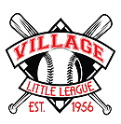

Lakewood Village Little League
Safety Manual 2022

Table of Contents
Table of Contents
LVLL Safety Mission Statement 3
Board Directory 4
Safety Plan Timeline 5
Lakewood Little League Safety Protocols 6
Accident Reporting 7
Background Checks 9
Media and Likeness Usage 11
League First Aid Kits 12
Safety Cards 14
Equipment 15
Field Inspection 16
Concession Stand Safety Protocols 17
Qualified Safety Plan and Player Data 20

Safety Mission Statement

Lakewood Village Little League is committed to providing a safe and fun experience for all players. All volunteers, players, and spectators will work together to ensure our Little League players continue to develop skills and grow their love for the game of baseball.

Lakewood Village Little League has developed A Safety Awareness Program (ASAP) with the mission to operate with a high level of safety awareness, committed to operate our league as the safest, most compliant league in alignment with Little League International for the players we serve.

We understand that preparation, prudence and participation will create the safest, most equitable experience. LVLL understands that in baseball, there is an inherent risk of injury, but our league safety manual aims to mitigate and reduce that risk as much as possible. It takes a village to ensure safety and enjoyment are the main takeaways from LVLL.

Board Directory
President | Joel Davis | president@villagebaseball.org | (562) 305-1104
Co-Vice Presidents | Geoff Delahanty  Adam Moss | vicepresident@villagebaseball.org  Gtd7411@gmail.com  Sfgiants075@yahoo.com | (310) 650-3218  (626) 523-8705
Secretary | Julie Sangkarat | info@villagebaseball.org | (562) 453-6740
Treasurer | Dave Wippel | treasurer@villagebaseball.org | (310) 913-5080
Player Agent | Josue Rodriguez | playeragent@villagebaseball.org | (213) 709-2160
Safety Officer | Ke’Len Armstrong | Mr.k.armstrong@gmail.com | (310) 493-7828
Auxiliary Board President | Erica Rodriguez | auxboardpresident@villagebaseball.org  ericajeanrodriguez@gmail.com | (714) 267-5147
Umpire-in-Chief | Matt Shahon | miraclematt@msn.com | (562) 706-4522
Majors VP | Rob Frazier | Robert.frazier002@gmail.com | (562) 756-1843
Minor A VP | Darren Johnson | dpjazzy@hotmail.com | (310) 617-7188
Minor B VP | David Heitz | 1dheitz@gmail.com | (310) 621-9691
Farm VP | Jon Fenoglio | Nukcurv51@mac.com | (714) 745-3495
Coach Pitch VP | Tish Febach | ticialanham@hotmail.com | (760) 777-5754
Coaching Coordinator | Misti Guenther | misti4hits17@gmail.com | (310) 773-1575
Uniform Manager | Leonora Shahon | uniformrep@villagebaseball.org | (562) 706-4533
Equipment Manager | Steve Quiroz | Squiroz81@gmail.com | (562) 537-5439
Sponsor/Publicity Chairperson | Vickie Wippel | publicity@villagebaseball.org | (310) 984-4501
Sponsorship Rep | Sara Vega | sponsorrep@villagebaseball.org | (562) 413-2975
Tournament Director | Kevin Nottage | kmnottage@gmail.com | (562) 208-7283
Concession Manager | Sarah Moss | sarahgreenstein@hotmail.com | (310) 422-1504
Web Manager | Alaine Williams | webmaster@villagebaseball.org  williams.house6253@gmail.com | (562) 841-4359
At Large | Stephen Padget | stevenpadgett@gmail.com | (562) 619-2454
At Large | Kellie Collins | Kelliecollins24@gmail.com | (562) 213-3100
At Large | Erin Peck | Erinpeck78@gmail.com | (562) 537-1807
At Large | Emily Clark | rjsc@me.com | (949) 295-5933
At Large | Alec Gilland | Gilliman22@hotmail.com | (310) 720-5812
At Large | Steve Ritchie | Ssritchie06@gmail.com | (541) 231-4282
At Large | Ben Kohlinger | Benjamin.koehlinger@gmail.com | (213) 675-0085
At Large | Yusef Williams | CoachYu614@gmail.com | (562) 786-9105
Lakewood Village Little League Safety Plan Timeline
Summer 2021
- LVLL Safety Officer reviewed safety protocols in preparation for revisions for the new League Year
September 2021
- LVLL Safety Officer collaborated with Little League International on improving the league’s safety plan and to check for possible compliance issues for the 2022 league year. Safety Officer adjusted the plan.
- LVLL Safety Officer met with LVLL President to discuss safety plans for the following year including possible protocols for future social distancing and sanitation requirements.
October 2021
- LVLL Safety Officer met with fellow league Safety Officers from other leagues to review best practices for the ASAP Safety Plan
December 2021
Completed final draft for Review from the President. Feedback was given and adjustments were made appropriately.
January 2022
- Safety plan was shared with the executive board
- Safety Plan was submitted to Little League International
- Safety meetings held for volunteers to review the 2022 LVLL ASAP Safety Plan.
February 2022
- League commences. Safety plan monitoring begins.

Lakewood Village Little League
Safety Protocols and Procedures 2022

*The following meets all 15 basic requirements as outlined by Little League International

Accident Reporting Procedures
An accident that causes any player, manager, coach, umpire, or volunteer to receive medical treatment or First Aid, must be reported immediately:
Safety Officer, Ke’Len Armstrong (safetylvll@gmail.com 310- 493-7828) or
League President, Joel Davis (president@villagebaseball.org).

Reporting Protocol
When reporting accidents, please provide the following information:
- Name(s) and phone number(s) of the person(s) involved
- Date, time, and location where the accident occurred
- A detailed description of what happened
- The type(s) of injury that occurred
- Name and phone number of the person reporting the accident
The Safety Officer must be contacted, and an Incident Injury Tracking Report and an Accident Claim Form will be completed.
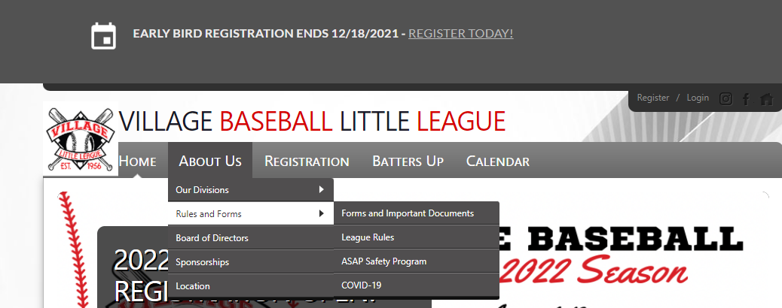
These forms can be found on the Lakewood Village League Website (http://www.villagebaseball.org/).

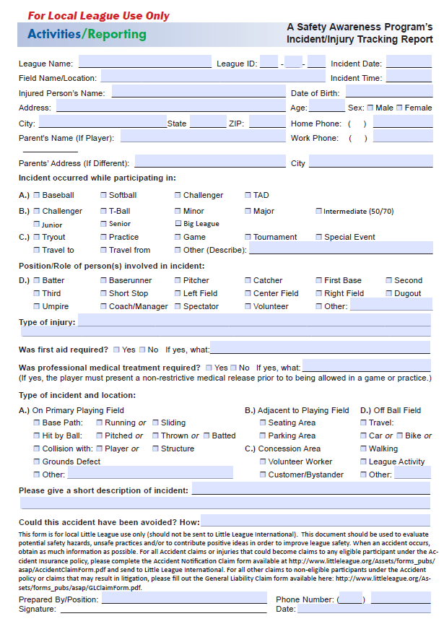

Once the Safety Officer receives the report, he will then:
- contact the injured person(s) – or their parents or guardians if they are not an adult and verify the information.
- Stay in contact with the injured person(s) to monitor the progress of the report.
- Provide all parties with the Lakewood Village Little League Insurance Information if necessary.
- Communicate with the board regarding incidents and all reported matters

Background Checks
Little League® regulations require any volunteer with repetitive access to children to consent to a national criminal background check, which includes a check of the National Sex Offender Registry database. To learn more about the background check process please visit the Little League International Website (https://www.littleleague.org/player-safety/child-protection-program/jdp-integration-with-sports-connect)
The League Safety Office will compile the information for league volunteers and enter them into the JD Palatine Background Check System. The Safety Officer will also monitor the status of all applications and communicate with the league president, team managers and coaches about the status of all volunteers.
Our background check procedure is:
- The Safety Officer enters the volunteer’s name and email address into JDP’s “QuickApp” system
- JDP’s QuickApp system sends the volunteer an email containing a link to submit their information
- The volunteer clicks on the link, and submits the information requested by JDP’s QuickApp system
- JDP conducts the background check, and the results become visible to the Safety Officer
- The Safety Officer reviews the results
- If the results contain no reportable records, the Safety Officer marks the person as “cleared”

- If the results contain records that indicate the volunteer is a potential risk to the players, volunteers, or Menifee Valley Little League itself, the Safety Officer contacts the League President, always protecting the identity of the volunteer, to discuss the risk and decide whether the volunteer is clear or not:
  - If a decision cannot be made, the League President would then contact the District Administrator for guidance in the matter
Possible Triggers for Unacceptable Application
Some crimes that would cause a volunteer to not be cleared for service in Lakewood Village Little League include:
- Child Abuse (of any degree or type)
- Child Molestation or any sexual or inappropriate interactions with minors
- Endangerment and Neglect of a Child; Risk of Injury to a Child
- Domestic Violence
- Violent Crime (of any kind)
- Terrorism or Terroristic Threats
- Stalking
- Restraining/Protective Order

Media and Likeness Usage
Lakewood Village Little League understands that spectators that attend our games and support our league love to do so using social media. While this is permitted to do, we must inform our teams, parents and volunteers about best practices to ensure that all parties are protected. Some families do not permit the league to take pictures and/or post images on any publications. To ensure this team managers and the safety manager will:
- Hold safety meeting with coaches to discuss the importance of maintaining safety via social media
- Meet with Parent volunteers to remind them of those expectations
- Disseminate the safety plan for all members to be aware of appropriate social media usage
  - IF recording a video, only record your child
  - Blur out all people that you do not have permission to post
  - Avoid tagging and labeling people on pictures or videos
  - Avoid sharing personal information about your child or other children on social media

League First Aid Kits
Lakewood Village Little League keeps a first-aid kit, extra supplies, and instant ice packs at the Concession stand located at the Minor A Field.
Each team will receive a first aid kit that is REQUIRED to be brought to all league sanctioned events (team practices, games, tournaments, etc.). Each team will also receive 2 ice packs. Additional ice packs will be available upon request. Coaches attend the league safety class and review the contents of the safety kits and how to use them.

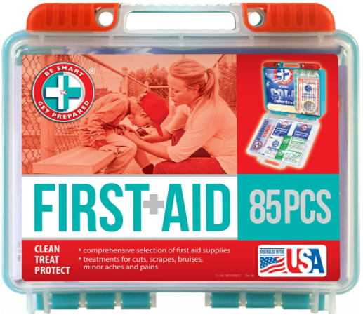

Injuries Requiring Ice
Ice is available at the concession stand. Coaches will be able to get ice bags from the concession stand when needed. For away games, the safety officer or coaches will check with the hosting park on ice availability (as well as other safety equipment).
Please follow accident reporting protocols when any injury requiring ice is needed. If the injury seems severe, please call 9-1-1.

Safety Cards
Every Coach and manager must have a valid Safety Card. To receive a training card, you must attend a sanctioned District 38 meeting. Please check with the safety officer regarding the status of your safety clearance. In this training, you must also have YEARLY certification of the following trainings:
- Sudden Cardiac Arrest
- Concussion Protocols
For more information on these protocols and trainings please see the Lakewood Village FAQ page using the following link: ibit.ly/FOBk

Equipment Safety
Equipment Safety Before each season, spring and fall, our Equipment Manager and Safety Officer will review updated guidelines for all equipment used for the season. This information will be disseminated to managers and coaches to support parents and players with securing all the necessary equipment to meet league compliance.
At the district safety meeting, managers and coaches will be trained on how to use the following equipment:
- First Aid Kit and accompanying safety materials
- AED machine (Anticipated for the 2022 Season)

League Provided Equipment
League provided equipment (such as baseballs, catchers gear, gloves etc.), will be inspected for safety and compliance. Any parents that provide equipment for their children can seek the input and approval for compliance of the safety manager. The safety manager may inspect equipment before, during or after a game to ensure compliance.
Before each game, our league sanctioned umpires will inspect game equipment – including bats, helmets, and catcher gear – to assure the equipment being used by the players is safe before the start of each game.

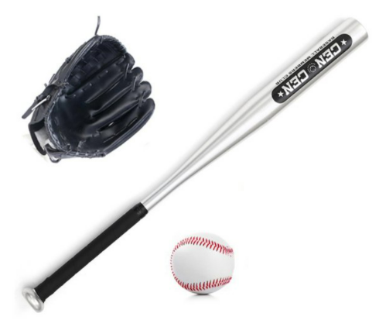
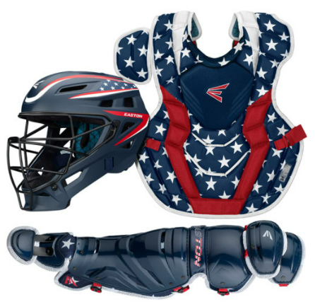

Field Inspection
A field inspection will be held frequently to ensure compliance and safety. Some of the inspection point include but are not limited to:
- break-away bases
- pitcher’s mound
- batter’s box
- dugouts
- bleachers
- infield
- Outfield
- Baselines
Each year the Safety Manager and Facilities manager will complete an Annual Facilities Survey to check all areas of the field. The status of the fields will be shared through text messages, the league website and through the league bulletin board.
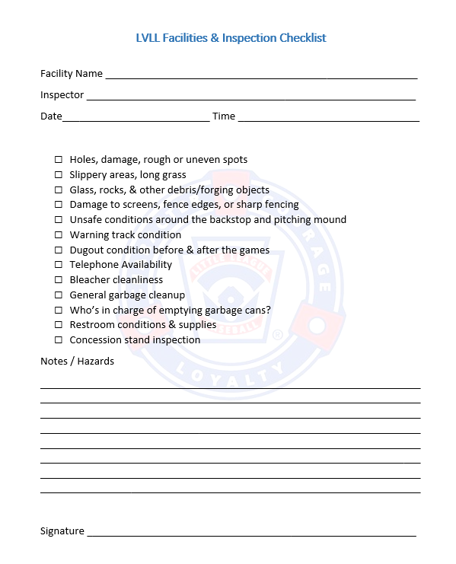

Concession Stand Protocols
Concession Stand Procedures Lakewood Village Little League values the health and safety of all supports and members of our league. Therefore, our approach to concession stand safety is focused on high quality service and safety and clean protocols: In the LVLL concession stand, the following procedures are expected to be always followed:
- Use of Food Handlers Gloves will always be enforced
- Use of appropriate procedures to ensure that all raw materials that require cooking will be safety to serve to the public.
- Access to clean running water and sink to wash utensils is provided
- All foods will be stored in appropriate containers
- Concession stand managers will check the expiration of all perishable items before use and will dispose of all unusable food material
- All volunteers will use clean materials including cooking surfaces, cooking utensils etc.
- All perishable food that is not sold shall be thrown out
- Only adults shall operate all cooking devices that require fire (charcoal or propane)
  - Proper training will be provided to volunteers on how to operate all cooking devices prior to usage
- All non-adult volunteers will be supervised by a designated league volunteer. No underage volunteers will be left unsupervised at any period.
- All workers within the snack-bar/concession-stand shall upon return from the restroom or the handling of any non-food item when they:
  - wash their hands in warm water (if available) and soap
  - Use hand sanitizer before continuing cooking
  - Replace previously used gloves with NEW, clean gloves
    - Important Note: Signs are posted in the bathrooms regarding the expectation of handwashing before returning to food services
    - All Volunteers that may have open sores, cuts, or oozing skin conditions may be prevented from working in the cooking/ food handling area unless the areas that are affected are protected and covered to prevent possible contamination.
- A local authority approved fire extinguisher is available for emergency use in the concession stand
  - All fire extinguishers:
    - must be checked annually and services as needed
    - will be refilled/recharged or changed out after usage or if deemed necessary to replace.
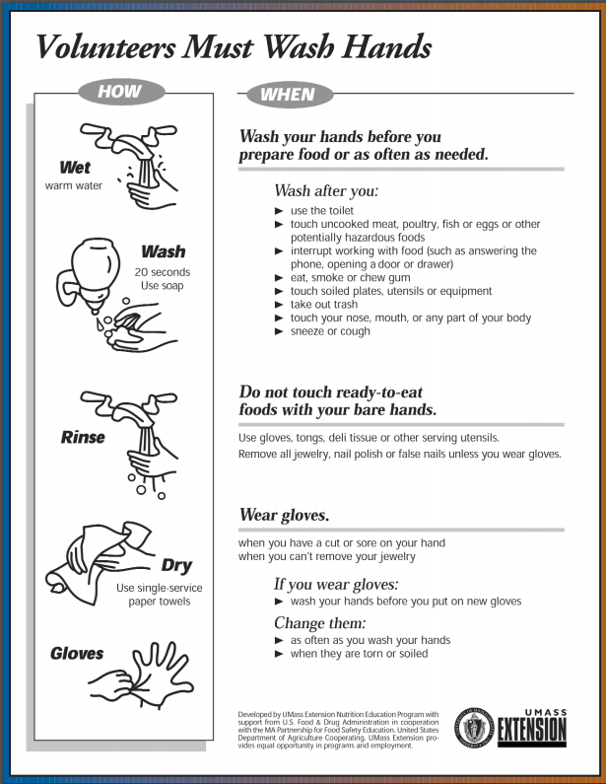
    - All concession stand volunteers will review how to use a fire extinguisher

Qualified Safety Plan and Player Data
The LVLL Board has compiled all necessary information from players and league volunteers and have submitted them to Little League International Data Center.
Volunteer Background Check Data will remain confidential and secure. Players and coaches that do not have appropriate documentation and paperwork will not be permitted to volunteer, coach, or attended league sanctioned events in any participatory manner.
All players will follow league age rules to ensure that appropriate skill level and age participates in games and tournaments.

